Project Design Phase
Solution Architecture

Date | 15 July 2026
Team ID | Team 1
Project Name | UNESCO World Heritage Site Analysis Using Tableau
Maximum Marks | 4 Marks

Solution Architecture:
The solution architecture describes the overall workflow of the project. UNESCO World Heritage data is collected from the dataset, cleaned and prepared, then imported into Tableau for analysis. Interactive dashboards are created using maps, charts, KPIs, and filters to visualize the data. Users can explore and analyse heritage sites to gain meaningful insights for research, education, tourism, and decision-making.
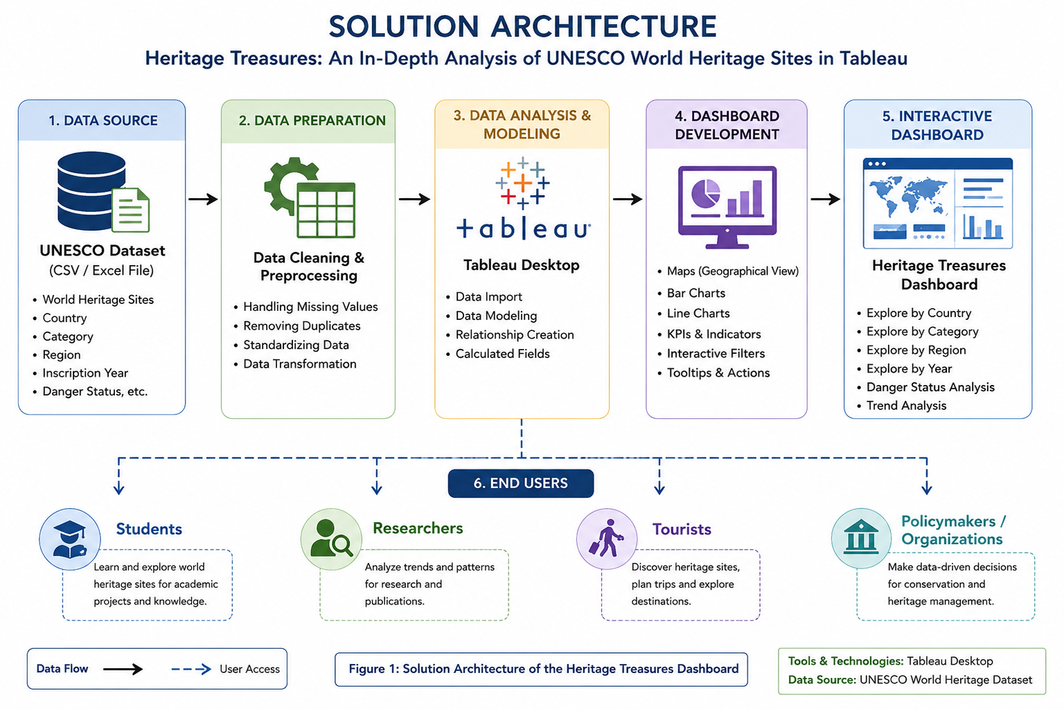
Figure 1: Solution Architecture of the Heritage Treasures Dashboard

